**Object Modelling and Design.**

**Practical 3.**

Code Base with SOLID Design Principles Implemented.

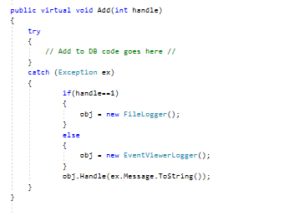

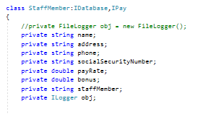

**Problems Encountered.**

**Problems:**

Had difficulties implementing “Dependency Inversion Principle”. I implemented it to the Add() method in StaffMember Class which used Interfaces : ILogger. The Add() code which is shown above is violating the principle die the “NEW” keyword. It is taking extra responsibilities of which object needs to be created.

**Solution:**

Invert this responsibility to something else rather the StaffMember class doing it would solve the problem to a certain extent. But there were errors I couldn’t solve and so, I have commented it out those errors.

**Other Problems encountered included.**

Residential Distance between team members. (Over come via services such as skype).

Conflicting schedules between team members. (Over come via scheduling dedicated time throughout the week).